Location: Situated in the southern and south-western part of Albania from Saranda to the South up to Vlora to the North. Its western border consists of Ionian Sea in the South and Adriatic Sea in the North, contoured by the following geographical co-ordinates:
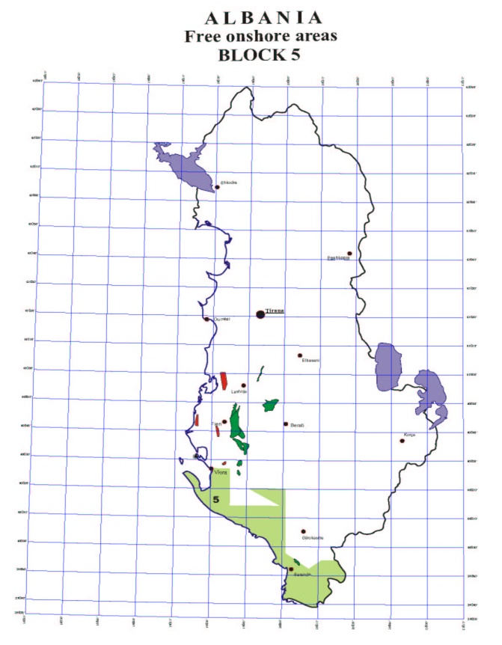
- 40º 27' 00" N 2. 40º 27' 00" N 3. 40º 14' 00" N
19º 29' 10" E 19º 37' 00" E 19º 37' 00" E
4. 40º 14' 00" N 5. 40º 20' 00" N 6. 40º 20' 00" N
19º 58' 00" E 19º 45' 00" E 20º 00' 00" E

7. 39º 57' 30" N 8. 39º 52' 00" N 9. 39º 55' 00" N 20º 00' 00" E 20º 09' 40" E 20º 15' 00" E
10. 39º 55' 00" N
20º 20' 50" E

