(Greece Albania Mobilization towards sustainable Energy for Students) GAMES Project

Summary
The G.A.M.E.S. project will be implemented by partners operating in the cross-border area:
-Greece:1 Regional body (Region of Epirus) located at the eligible Greek area, 1 National entity (CRES) responsible for the promotion of RES and EE, operates in the whole country.
-Albania:1 National body (NANR) responsible for the development of energy policies and strategies, operates in the whole country as well.
Small-scale RES and EE investments in public facilities will be realized in selected places of the eligible area in Greece and Albania.
The small-scale investments have been selected to be implemented in three educational and cultural building complexes centrally placed in Ioannina, Himara and Dropulli. They all include large open spaces that can be used as meeting points for their students, but also for visiting students from different regions of the cross-border area.
The project will follow a clear governance structure based on a joint management process and a strong supervision by the LP (RoE), which possesses significant experience in project coordination and managing transnational cooperation projects. The LP is responsible for the overall organization and management, the controls of project implementation and the activities of all the PPs, the coordination of the Steering Committe (SC) and Technical Committee (TC), while it also monitors and evaluates the quality of the work through a specific project management and quality guide, approved by the SC, supported by the TC, and through semiannual SC&TC meetings. The SC has determinative powers over the project, with each partner having one vote. In the case of an equal vote, the LP vote is decisive. The project management and quality guide constitutes a monitoring and evaluation system with guidelines on how the quality of the work is assessed and the activities will be effectively carried out.
RoE as LP will be responsible for the day-to-day follow up and administrative and financial management, and will coordinate activities to support project objectives in order to ensure the timely development & finalization of related deliverables. The LP having a long track record of approved transnational project management, will provide the partners with all the necessary tools and support for smooth project implementation and will handle the communication with the MA/JS and the preparation and submission of PR(s) on time. The LP is also responsible for submitting the Progress Reports, after collecting relevant information from the other partners. The LP will keep daily communication with partners via emails, skype and phone calls. The LP prepares an Internal Project Evaluation Methodology and Report indicating the achievements and deliverables developed and the aspects to be improved or modified for the future capitalization of the project.
Project Partner
Region of Epirus
Centre for Renewable Energy Sources and Saving
National Agency of Natural Resources

Priority Axis | 1. Promotion of the environment & sustainable transport and public infrastructure
Thematic Priority | 1b. Protecting the environment & promoting climate change adaptation & mitigation, risk prevention & management through, inter alia: joint actions for environmental protection; promoting sustainable use of natural resources, resource efficiency, renewable energy sources and the shift towards a safe and sustainable low-carbon economy promoting investment to address specific risks, ensuring disaster resilience and developing disaster management systems and emergency preparedness.
Specific Objective | 1.3 Increase energy efficiency and the use of RES

Project duration | Start | End | Total Months
 | 1/4/2019 | 31/10/2021 | 24

- Project Demonstration in Albania
Demonstrative Small-Scale Investments in Himara and Dropulli' Schools

1. Short General Description of the G.A.M.E.S. Small-Scale Investments

1..1 Himara
The RES and Energy Efficiency measures shall concentrate on the building envelopes, the heating/cooling/ventilation and electrical/illumination systems, sanitation as well as the replacement of old windows. Special attention should be given to a potential use of RES. Average energy savings of at least 40% for public kinder garden building shall be reached as a benchmark.
The Program does not claim to have a broad impact on overall energy consumption in Himara Municipality but rather to demonstrate the benefits of Energy Efficiency-lead refurbishment. By achieving the objective, the owner of the refurbished buildings shall benefit from reduced energy costs and the users from more comfort due to better living and working conditions. Furthermore, the Municipality as public building and pilot demonstration project shall be made aware of the advantages of investing in RES and energy efficiency measures. Moreover, a selected room will be equipped with pcs in order students or other visitors will be able to monitor the energy consumption of the building and will learn more about energy efficiency and the environmental impact.

1.2 Dropulli
The energy efficiency measures shall concentrate on the building envelopes, the heating/cooling/ventilation and electrical/illumination systems, sanitation as well as the replacement of old windows. Special attention should be given to a potential use of RES. Average energy savings of at least 40% for public kinder garden building shall be reached as a benchmark.
The Program does not claim to have a broad impact on overall energy consumption in Dropulli Municipality but rather to demonstrate the benefits of energy efficiency-lead refurbishment. By achieving the objective, the owner of the refurbished buildings shall benefit from reduced energy costs and the users from more comfort due to better living and working conditions. Furthermore, the municipality as public building and pilot demonstration project shall be made aware of the advantages of investing in energy efficiency measures.

1.3 Justification of the of the G.A.M.E.S. Small-Scale Investments

1.3.1 Himara
A common challenge in the area is the lack of incorporating sustainable energy technologies and using ICT technologies in the public buildings and open spaces. It is also important to create joint public awareness initiatives especially to students. The small-scale investments in High school Qazim Pali Borsh with open spaces and the joint public awareness initiatives should effectively familiarize the citizens with all the advantages of energy efficiency and RES (e.g. economical, thermal comfort, environmental).
The planned actions are directly linked with the core of Priority Axis 1 of the cross-border programme, since it will implement small scale investments in energy efficiency and use of RES in public buildings and public spaces, will utilize advanced Information and Communications Technology (ICT) and promote joint public awareness initiatives for energy efficiency and the use of RES primarily in students and as a consequence in the rest of the eligible area citizens.

1.3.2 Dropulli
A common challenge in the area is the lack of incorporating sustainable energy technologies and using ICT technologies in the public buildings and open spaces. It is also important to create joint public awareness initiatives especially to students. The small-scale investments in Dropulli culture building with open spaces and the joint public awareness initiatives should effectively familiarize the citizens with all the advantages of energy efficiency and RES (e.g. economical, thermal comfort, environmental).
Achieving the objective, are absolutely necessary to strengthen the use of energy efficiency and RES at public buildings to improve the students and resident’s activation in these fields, to raising awareness and to increase the penetration of these technologies. The planned small-scale investments are directly linked with the core of Priority Axis 1 of the cross-border programme, since it will implement small scale investments in energy efficiency and use of RES in public buildings and public spaces, will utilize advanced ICT and promote joint public awareness initiatives for energy efficiency and the use of RES primarily in students and as a consequence in the rest of the eligible area citizens.

Description of the G.A.M.E.S. Small-Scale Investments

2.1 Short Technical Description

2.1.1 High School “Qazim Pali” Borsh (Himara)
The High School “Qazim Pali” Borsh of municipality of Himara has one part two floors and other part tree floors. During its operation of 40 years this building has been renovated with small intervention on 1999 but there has never been done any work in improving the energy efficiency. The building has an area of 2500 m2 consisting of 30 Doors, 50 windows. The first floor of the building has an area of ​​1005 m2, second and third floor 1445 m2. The building has a roof terrace with surface 500 m2 and tarace 500 m². Building has a school yard with capacity 2030 m³. The school is frequented by 160 students and 350 visitors.
The building does not have a central heating, the incandescent lighting and electrical system is not efficient, and neither the walls nor the roof are not insulated.
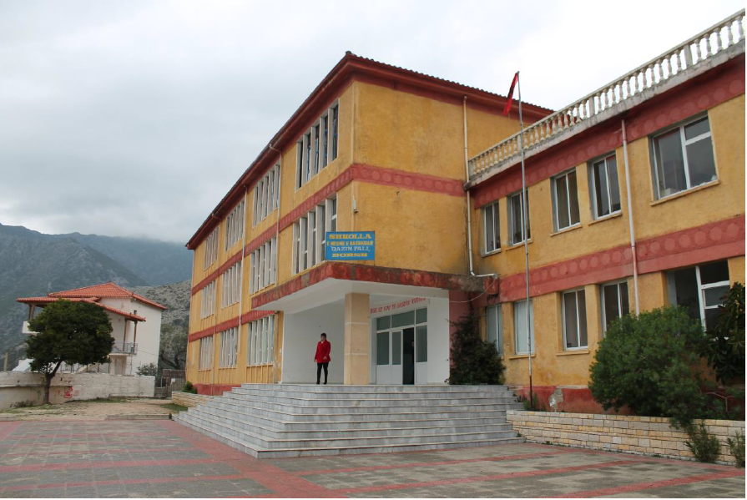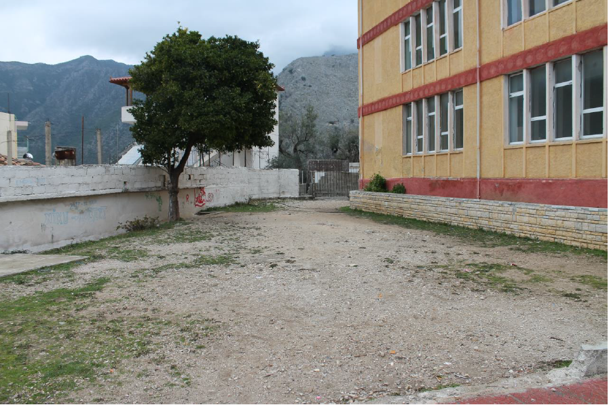
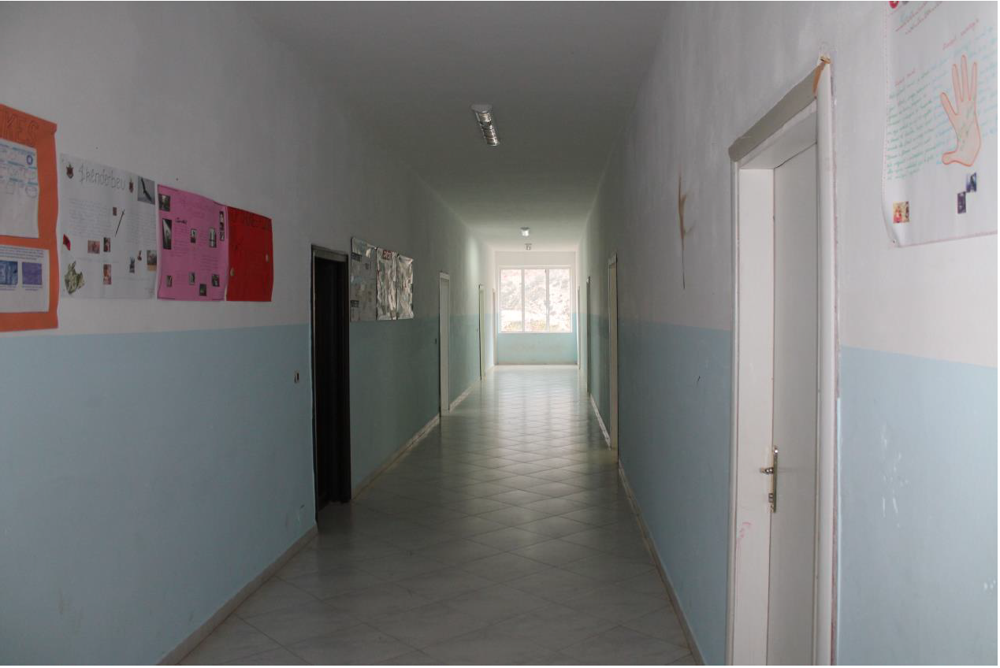

Photo 3: High School “Qazim Pali” Borsh of Municipality Himara
Action of intervention for integration of Energy Efficiency measures and RES:
- Installation of external thermal insulation at the outside walls
- Installation of external thermal insulation in the roof/terrace
- Installation of double-glazed windows and one new door
- Installation the district heating system
- Renovation of the electricity system (wiring, main switches, fuses, lighting, plugs, smoke detectors) and installation of efficient Lighting.
- Installation solar panel for hot water.
- Installation of the energy meters and the BMS system and installation of PCs in a selected extra room for education and monitor the energy consumption of the building and will learn more about energy efficiency and the environmental impact.

2.1.2 Culture Building Delvicjan (Dropulli)
The Culture Building Delvicjan, of municipality of Dropull has two floors and locate in center of village. During its operation of 50 years this building has been renovated with small intervention on 2001 and 2004 but there has never been done any work in improving the energy efficiency. The building has an area of 600 m2 consisting of 18 Doors, 20 windows. The first floor of the building has an area of ​​600 m2, and second floor 550 m2. The building has a roof with surface 400 m2 and tarace 170 m². Building has a school yard with capacity 1700 m³
The building does not have a central heating, the lighting and electrical system is not efficient, and neither the walls nor the roof are not insulated.
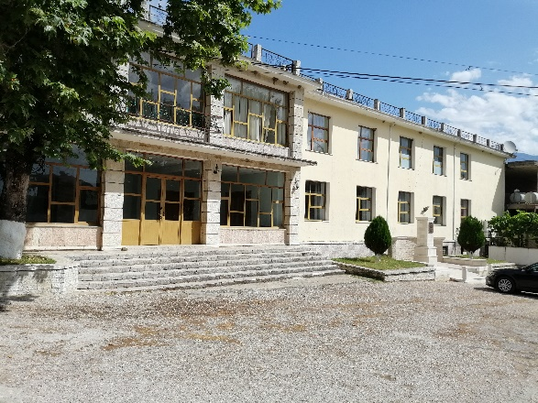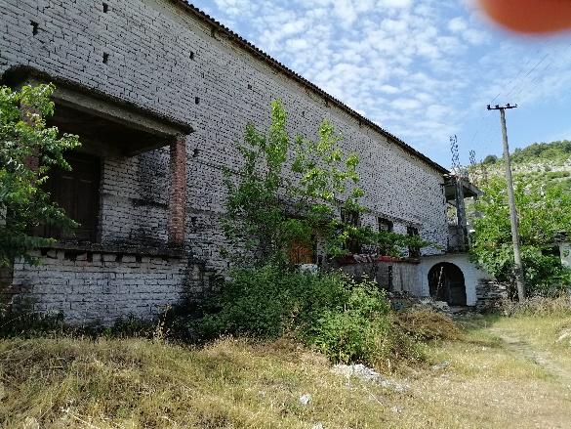
Photo 4: Culture Building Delvicjan, of Municipality Dropull
Action of intervention for integration of energy efficiency measures and RES are summarized as follows:
- Installation of external thermal insulation in the outside walls
- Installation of external thermal insulation in the roof/terrace
- Replacement of the roof with a new more stable so to tolerate the weight of the insulation and solar panels.
- Installation of double-glazed windows, one central door and two doors for
- Installation the district heating system
- Renovation of the electricity system (wiring, main switches, fuses, lighting, plugs, smoke detectors) and installation of efficient Lighting.
- Installation solar panel for hot water.
- Installation of energy meters

2.2 Expected Results

2.2.1 Himara
The specific energy consumption for Albania case is more than 188 kWh / m2 year - which indicates on the basis of the European Certificate can be classified as a G building as it is consumed higher than 156 kWh / m2 per year. Our target will be class E 101-125 kWh / m2 year.

2.2.2 Dropulli
The specific energy consumption for Albania case is more than 188 kWh / m2 year - which indicates on the basis of the European Certificate can be classified as a G building as it is consumed higher than 156 kWh / m2 per year. Our target will be class E 101-125 kWh / m2 year.

