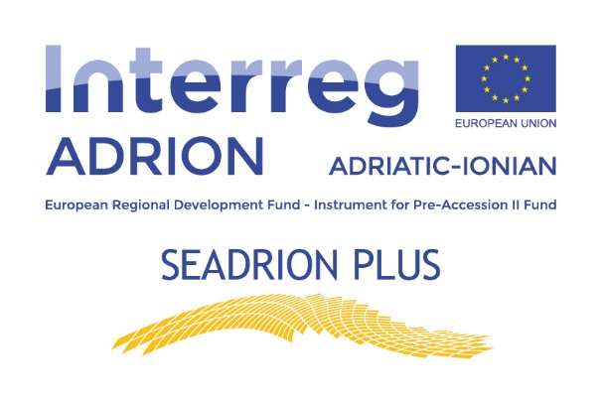

SEADRION PLUS, Fostering diffusion of Heating & Cooling technologies using the seawater pump in the Adriatic-Ionian Region PLUS.

Project SEADRION was a great success, with the main results being the installation of three seawater heat pumps used for various applications and the development of a web platform that offers a valuable tool for networking and exchange of knowledge for interested parties. Besides, on the web platform are displayed information and results for one pilot plant, which is beneficial for further analysis and enhancement of such systems. To extend the knowledge obtained during the project activities and bring the project results and achievements to the even broader public, SEADRION+ will focus on dissemination and promotional actions about the possibilities of deploying seawater heat pump systems. The actions foreseen in the project
SEADRION PLUS include the organisation of dedicated dissemination events such as open days, seminars, and workshops. Due to the present danger of COVID-19 outbreaks, all events will be held in hybrid mode with on-site presentations and online streaming events. The main events of the project will be promotional seminars on practical applications of seawater heat pump systems at three pilot sites in Crikvenica, Dubrovnik, and Alexandroupolis. Nevertheless, to increase the awareness of benefits derived from the SEADRION project, all partners will organise the open-days events at their centers or sites with an example of good practice to reach an even broader public and provide crucial information about similar project developments. Such activities will directly contribute to the overall goals of increasing awareness and promoting the project outcomes and results to targeted stakeholders and potential beneficiaries on national and regional levels. Especially, it is of great interest to promote the installed systems at pilot sites since they are used for different purposes with a remarkable success that resulted in energy savings and reduced environmental footprint. Furthermore, all partners will organise workshops and seminars to promote the project outcomes and tools presented at web-platform developed during the initial SEADRION project.
It is essential to ensure the knowledge transfer between project partners and potential beneficiaries, including project developers, energy agencies, and public authorities in the first place, but also research and academy institutions, various NGOs, and other concerned stakeholders by giving them first-hand information. Finally, all partners together will organise one final event in the form of the conference that will aim to bring all considered stakeholders at one place to promote the project outcomes, foster networking among them, and ensure the transfer of knowledge and examples of good practice. SEADRION PLUS is an essential component to ensure the durability of the project outcomes from the initial project, but even more to extend and exchange the obtained knowledge between project partners and different stakeholders to foster deployment of seawater heat pumps on a greater scale.

